Computing Programming Homework - Milk Bottles

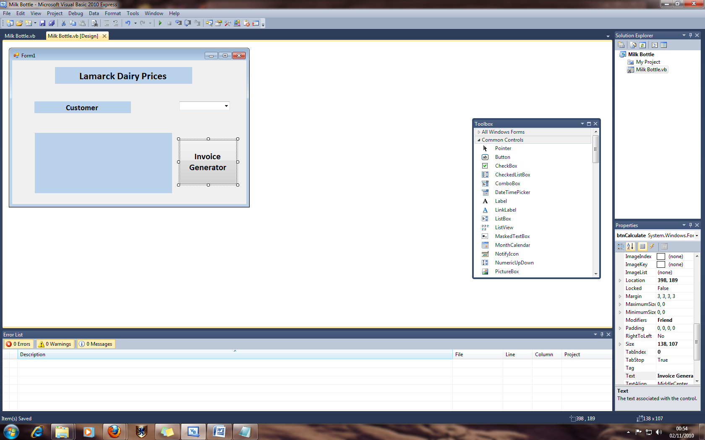Form

I have use a combo box so when the program is up and running, a list of potential customers could be selected from the drop down list. This, in turn, would change the Invoice displayed.

Code

Public Class Form1

Dim Price As Single

Dim Priceperpint As Single

Dim MilkQuantity As Integer

Dim OutputWholesale As String

Dim OutputSainsbury As String

Dim OutputMorrison As String

Dim OutputBooths As String

Private Sub btnCalculate_Click(ByVal sender As System.Object, ByVal e As System.EventArgs) Handles btnCalculate.Click

MilkQuantity = InputBox("Enter The Amount of Milk Bottles", "Milk Purchase", 0)

OutputWholesale = "Customer: "

If cboCustomer.SelectedItem = "Wholesale" Then

If MilkQuantity < 1000 Then

Priceperpint = 0.13

Price = Priceperpint * MilkQuantity

OutputWholesale = OutputWholesale & "Wholesale" & vbNewLine & _

"Price Per Pint: " & Format(Priceperpint, "currency") & vbNewLine & _

"Quantity: " & MilkQuantity & vbNewLine & _

"Total Cost: " & Format(Price, "currency")

ElseIf MilkQuantity < 2000 Then

Priceperpint = 0.11

Price = Priceperpint * MilkQuantity

OutputWholesale = OutputWholesale & "Wholesale" & vbNewLine & _

"Price Per Pint: " & Format(Priceperpint, "currency") & vbNewLine & _

"Quantity: " & MilkQuantity & vbNewLine & _

"Total Cost: " & Format(Price, "currency")

ElseIf MilkQuantity >= 2000 Then

Priceperpint = 0.1

Price = Priceperpint * MilkQuantity

OutputWholesale = OutputWholesale & "Wholesale" & vbNewLine & _

"Price Per Pint: " & Format(Priceperpint, "currency") & vbNewLine & _

"Quantity: " & MilkQuantity & vbNewLine & _

"Total Cost: " & Format(Price, "currency")

End If

End If

OutputSainsbury = "Customer: "

If cboCustomer.SelectedItem = "Sainsbury" Then

If MilkQuantity < 1000 Then

Priceperpint = 0.12

Price = Priceperpint * MilkQuantity

OutputSainsbury = OutputSainsbury & "Sainsbury" & vbNewLine & _

"Price Per Pint: " & Format(Priceperpint, "currency") & vbNewLine & _

"Quantity: " & MilkQuantity & vbNewLine & _

"Total Cost: " & Format(Price, "currency")

ElseIf MilkQuantity < 2000 Then

Priceperpint = 0.1

Price = Priceperpint * MilkQuantity

OutputSainsbury = OutputSainsbury & "Sainsbury" & vbNewLine & _

"Price Per Pint: " & Format(Priceperpint, "currency") & vbNewLine & _

"Quantity: " & MilkQuantity & vbNewLine & _

"Total Cost: " & Format(Price, "currency")

ElseIf MilkQuantity >= 2000 Then

Priceperpint = 0.09

Price = Priceperpint * MilkQuantity

OutputSainsbury = OutputSainsbury & "Sainsbury" & vbNewLine & _

"Price Per Pint: " & Format(Priceperpint, "currency") & vbNewLine & _

"Quantity: " & MilkQuantity & vbNewLine & _

"Total Cost: " & Format(Price, "currency")

End If

End If

OutputMorrison = "Customer: "

If cboCustomer.SelectedItem = "Morrison" Then

If MilkQuantity < 1000 Then

Priceperpint = 0.1

Price = Priceperpint * MilkQuantity

OutputMorrison = OutputMorrison & "Morrison" & vbNewLine & _

"Price Per Pint: " & Format(Priceperpint, "currency") & vbNewLine & _

"Quantity: " & MilkQuantity & vbNewLine & _

"Total Cost: " & Format(Price, "currency")

ElseIf MilkQuantity < 2000 Then

Priceperpint = 0.09

Price = Priceperpint * MilkQuantity

OutputMorrison = OutputMorrison & "Morrison" & vbNewLine & _

"Price Per Pint: " & Format(Priceperpint, "currency") & vbNewLine & _

"Quantity: " & MilkQuantity & vbNewLine & _

"Total Cost: " & Format(Price, "currency")

ElseIf MilkQuantity >= 2000 Then

Priceperpint = 0.07

Price = Priceperpint * MilkQuantity

OutputMorrison = OutputMorrison & "Morrison" & vbNewLine & _

"Price Per Pint: " & Format(Priceperpint, "currency") & vbNewLine & _

"Quantity: " & MilkQuantity & vbNewLine & _

"Total Cost: " & Format(Price, "currency")

End If

End If

OutputBooths = "Customer: "

If cboCustomer.SelectedItem = "Booths" Then

If MilkQuantity < 1000 Then

Priceperpint = 0.15

Price = Priceperpint * MilkQuantity

OutputBooths = OutputBooths & "Booths" & vbNewLine & _

"Price Per Pint: " & Format(Priceperpint, "currency") & vbNewLine & _

"Quantity: " & MilkQuantity & vbNewLine & _

"Total Cost: " & Format(Price, "currency")

ElseIf MilkQuantity < 2000 Then

Priceperpint = 0.11

Price = Priceperpint * MilkQuantity

OutputBooths = OutputBooths & "Booths" & vbNewLine & _

"Price Per Pint: " & Format(Priceperpint, "currency") & vbNewLine & _

"Quantity: " & MilkQuantity & vbNewLine & _

"Total Cost: " & Format(Price, "currency")

ElseIf MilkQuantity >= 2000 Then

Priceperpint = 0.06

Price = Priceperpint * MilkQuantity

OutputBooths = OutputBooths & "Booths" & vbNewLine & _

"Price Per Pint: " & Format(Priceperpint, "currency") & vbNewLine & _

"Quantity: " & MilkQuantity & vbNewLine & _

"Total Cost: " & Format(Price, "currency")

End If

End If

If cboCustomer.SelectedItem = "Wholesale" Then

lblInvoice.Text = "Lamarck Dairy – Order" & vbNewLine & _

OutputWholesale

End If

If cboCustomer.SelectedItem = "Sainsbury" Then

lblInvoice.Text = "Lamarck Dairy – Order" & vbNewLine & _

OutputSainsbury

End If

If cboCustomer.SelectedItem = "Morrison" Then

lblInvoice.Text = "Lamarck Dairy – Order" & vbNewLine & _

OutputMorrison

End If

If cboCustomer.SelectedItem = "Booths" Then

lblInvoice.Text = "Lamarck Dairy – Order" & vbNewLine & _

OutputBooths

End If

End Sub

End Class

Examples:

Sainsbury - 950 pints

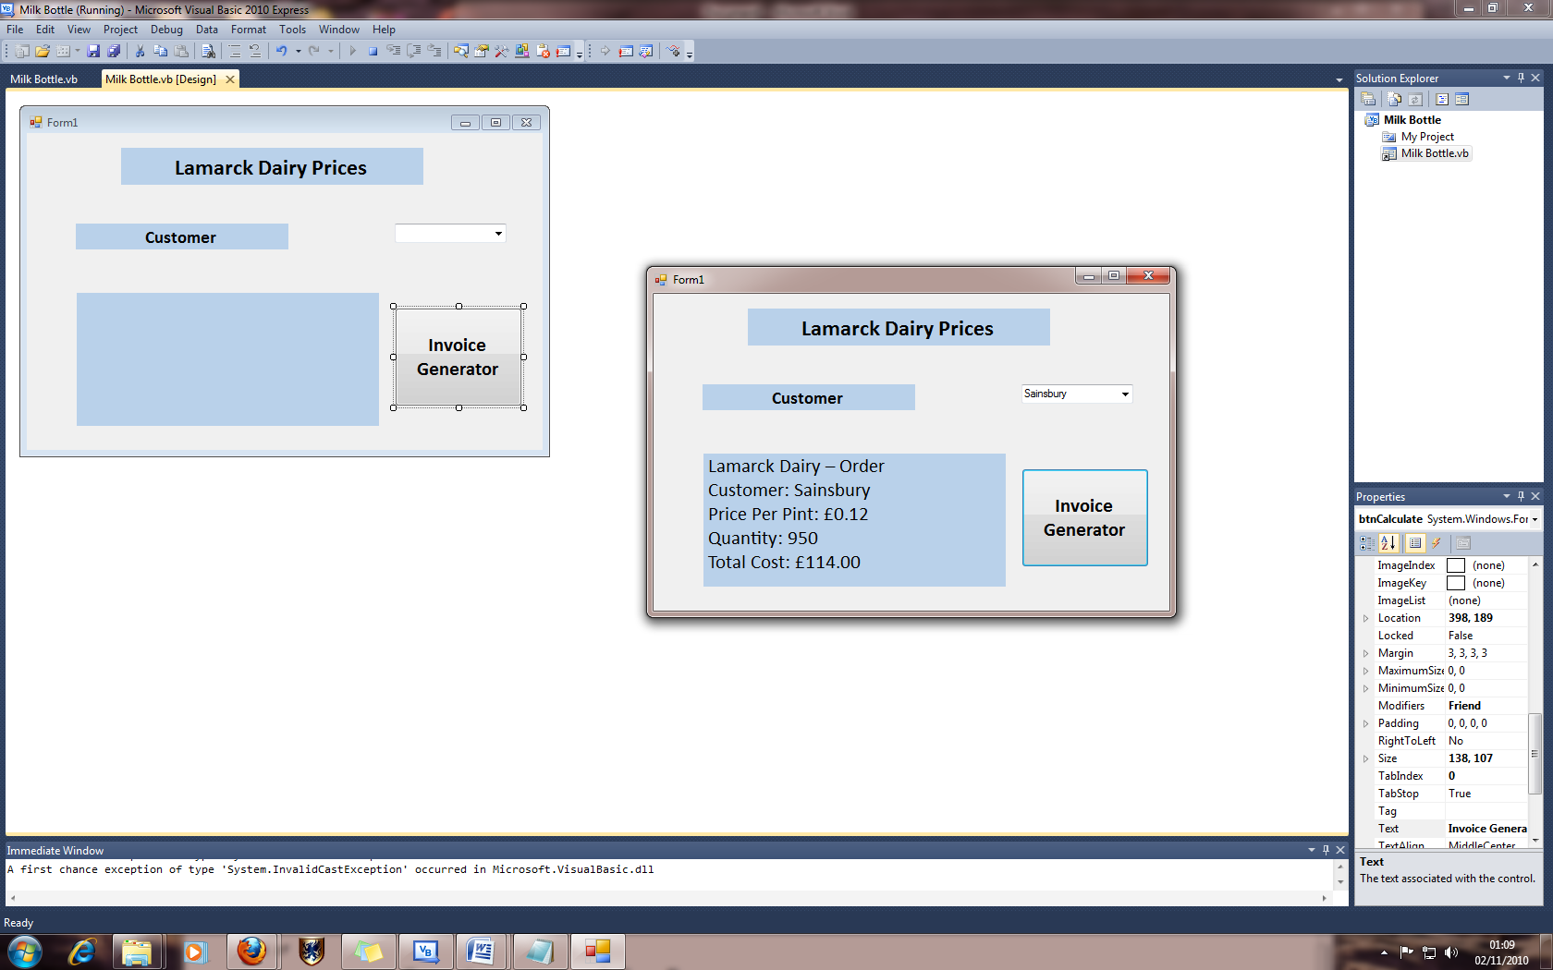

Booths - 2150 pints

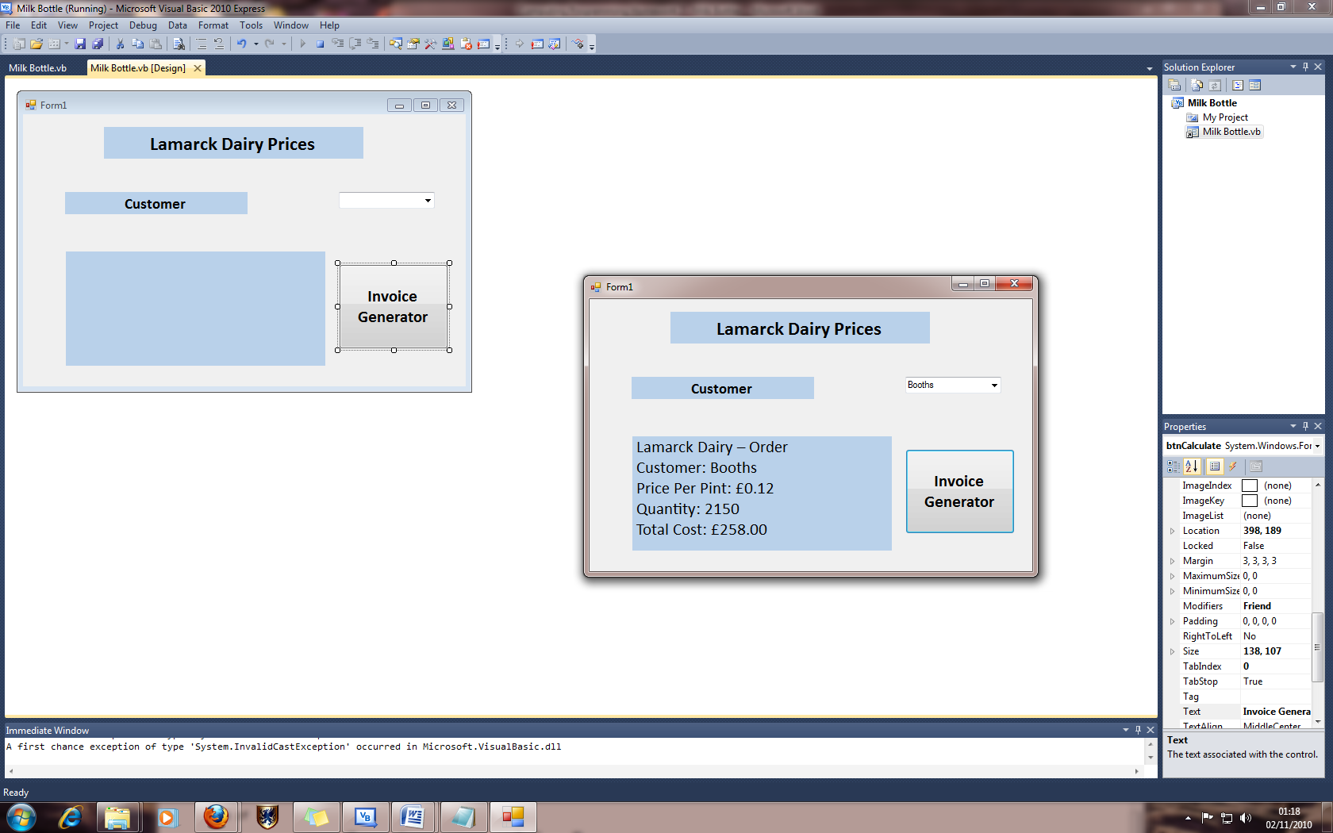

Morrison - 1860 pints

